**To Predict the Chronic Disease Using Linear Classification Algorithm**

1. **) SUPPORT VECTOR MACHINE**

Using Support Vector Machine algorithm, we got the best model with these hyper tuning parameters

**BEST MODEL : {kernal: linear, C: 100, gamma: scale}**

|  |  |  |  |
| --- | --- | --- | --- |
| **SNO** | **KERNAL** | **GAMMA** | **HYPER**  **PARAMETER** |
| 1 | LINEAR | SCALE | C100 |
| 2 | LINEAR | SACLE | C150 |
| 3 | LINEAR | AUTO | C100 |
| 4 | LINEAR | AUTO | C150 |
| 5 | RBF | SCALE | C100 |
| 6 | RBF | SACLE | C150 |
| 7 | RBF | AUTO | C100 |
| 8 | RBF | AUTO | C150 |
| 9 | SIGMOID | SCALE | C100 |
| 10 | SIGMOID | SACLE | C150 |
| 11 | SIGMOID | AUTO | C100 |
| 12 | SIGMOID | AUTO | C150 |

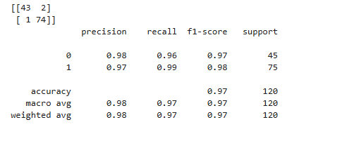

1. **)DECISION TREE:**

Using Decision Tree algorithm, we got the best model with these hyper tuning parameters

**BEST MODEL : {criterion: log_loss, max_features: log2, splitter: random}**

|  |  |  |  |
| --- | --- | --- | --- |
| **SL_NO** | **CRITERION** | **MAX FEATURES** | **SPLITTER** |
| 1 | GINI | SQRT | BEST |
| 2 | GINI | SQRT | RANDOM |
| 3 | GINI | LOG2 | BEST |
| 4 | GINI | LOG2 | RANDOM |
| 5 | ENTROPY | SQRT | BEST |
| 6 | ENTROPY | SQRT | RANDOM |
| 7 | ENTROPY | LOG2 | BEST |
| 8 | ENTROPY | LOG2 | RANDOM |
| 9 | LOG_LOSS | SQRT | BEST |
| 10 | LOG_LOSS | SQRT | RANDOM |
| 11 | LOG_LOSS | LOG2 | BEST |
| 12 | LOG_LOSS | LOG2 | RANDOM |

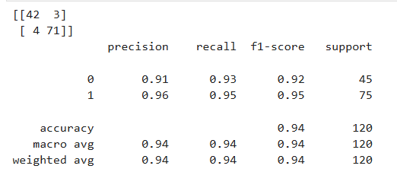

1. **RANDOM FOREST:**

Using Random Forest algorithm, we got the best model with the hyper tuning parameters

**BEST MODEL : {'criterion': gini, 'max_features': sqrt, 'n_estimators': 500}**

|  |  |  |  |
| --- | --- | --- | --- |
| **SL_NO** | **CRITERION** | **MAX FEATURES** | **N_ESTIMATORS** |
| 1 | ENTROPY | NONE | 50 |
| 2 | ENTROPY | NONE | 100 |
| 3 | ENTROPY | NONE | 250 |
| 4 | ENTROPY | NONE | 500 |
| 5 | ENTROPY | NONE | 1000 |
| 6 | ENTROPY | LOG2 | 50 |
| 7 | ENTROPY | LOG2 | 100 |
| 8 | ENTROPY | LOG2 | 250 |
| 9 | ENTROPY | LOG2 | 500 |
| 10 | ENTROPY | LOG2 | 1000 |
| 11 | ENTROPY | SQRT | 50 |
| 12 | ENTROPY | SQRT | 100 |
| 13 | ENTROPY | SQRT | 250 |
| 14 | ENTROPY | SQRT | 500 |
| 15 | ENTROPY | SQRT | 1000 |
| 16 | GINI | NONE | 50 |
| 17 | GINI | NONE | 100 |
| 18 | GINI | NONE | 250 |
| 19 | GINI | NONE | 500 |
| 20 | GINI | NONE | 1000 |
| 21 | GINI | LOG2 | 50 |
| 22 | GINI | LOG2 | 100 |
| 23 | GINI | LOG2 | 250 |
| 24 | GINI | LOG2 | 500 |
| 25 | GINI | LOG2 | 1000 |
| 26 | GINI | SQRT | 50 |
| 27 | GINI | SQRT | 100 |
| 28 | GINI | SQRT | 250 |
| 29 | GINI | SQRT | 500 |
| 30 | GINI | SQRT | 1000 |
| 31 | LOG_LOSS | NONE | 50 |
| 32 | LOG_LOSS | NONE | 100 |
| 33 | LOG_LOSS | NONE | 250 |
| 34 | LOG_LOSS | NONE | 500 |
| 35 | LOG_LOSS | NONE | 1000 |
| 36 | LOG_LOSS | LOG2 | 50 |
| 37 | LOG_LOSS | LOG2 | 100 |
| 38 | LOG_LOSS | LOG2 | 250 |
| 39 | LOG_LOSS | LOG2 | 500 |
| 40 | LOG_LOSS | LOG2 | 1000 |
| 41 | LOG_LOSS | SQRT | 50 |
| 42 | LOG_LOSS | SQRT | 100 |
| 43 | LOG_LOSS | SQRT | 250 |
| 44 | LOG_LOSS | SQRT | 500 |
| 45 | LOG_LOSS | SQRT | 1000 |

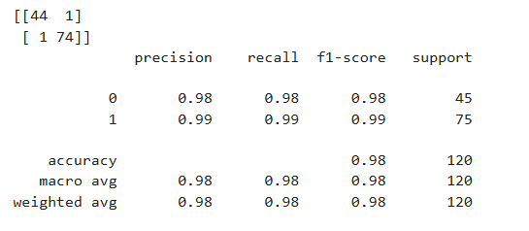

**Got Best Model with 98 % of Accuracy using Random Forest**

1. **LOGISTIC REGRESSION MODEL:**

Using Logistic Regression algorithm, we got the best model with the hyper tuning parameters

**BEST MODEL : {C : 1.0}**

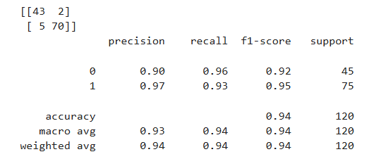

1. **KNN MODEL:**

Using Logistic Regression algorithm, we got the best model with the hyper tuning parameters

BEST MODEL : {'algorithm': 'auto', 'metric': 'minkowski', 'n_neighbors': 10}

|  |  |  |  |
| --- | --- | --- | --- |
| **SL_NO** | **METRIC** | **ALGORITHM** | **N_NEIGHBORS** |
| 1 | MINKOWSKI | AUTO | 5 |
| 2 | MINKOWSKI | AUTO | 10 |
| 3 | MINKOWSKI | AUTO | 100 |
| 4 | MINKOWSKI | AUTO | 150 |
| 5 | MINKOWSKI | AUTO | 200 |
| 6 | MINKOWSKI | BALL_TREE | 5 |
| 7 | MINKOWSKI | BALL_TREE | 10 |
| 8 | MINKOWSKI | BALL_TREE | 100 |
| 9 | MINKOWSKI | BALL_TREE | 150 |
| 10 | MINKOWSKI | BALL_TREE | 200 |
| 11 | MINKOWSKI | KD_TREE | 5 |
| 12 | MINKOWSKI | KD_TREE | 10 |
| 13 | MINKOWSKI | KD_TREE | 100 |
| 14 | MINKOWSKI | KD_TREE | 150 |
| 15 | MINKOWSKI | KD_TREE | 200 |
| 16 | MINKOWSKI | BRUTE | 5 |
| 17 | MINKOWSKI | BRUTE | 10 |
| 18 | MINKOWSKI | BRUTE | 100 |
| 19 | MINKOWSKI | BRUTE | 150 |
| 20 | MINKOWSKI | BRUTE | 200 |

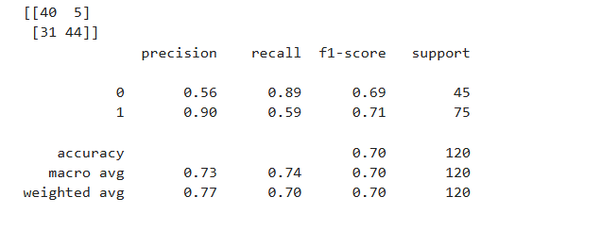

1. **Gaussian NB**

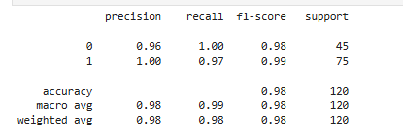

1. **Multinomial NB**

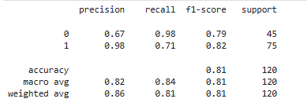

1. **Complement NB**

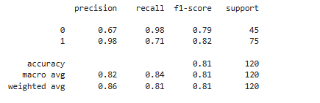

1. **Bernoulli NB**

